[Email](mailto:terracottaarmy81@gmail.com)  
480-859-1472

**JEREMIAH BROCKETT**

|  |  |
| --- | --- |
| Skills & Abilities | * Familiar with hydraulic/pneumatic and electrical schematics. * Experienced with cleanroom environments and adhering to OSHA standards. * Troubleshooting. * Attention to detail. * Experienced in AutoCAD and the Microsoft Office Suite. * Diligent employee, respectable attendance record. * Able to work individually, or in a team environment. |
| Professional Experience | **Manufacturing Associate 2 Eastridge Agency| Dexcom****May 2019 – Current**  * Responsible for the kitting duties including inspecting materials, adjusting, and pulling finished product from the line. * Works from process or written and verbal instructions given by supervisor to perform production work. * Operates hand tools and other equipment as needed.  **line cook| islamorada fish company****aug 2018 – may 2019**  * Prepared and served seafood items in a fast-paced environment. * Worked in an open kitchen where customers could observe meal preparation.  **chef assistant| SASSI italian restaurant** **feb 2018 – may 2018**  * Worked directly under executive chef and head chefs. * Created fine dining cuisine of epicurean delights.  **grill/prep cook | alamo drafthouse cinema****jan 2017 – jan 2018**  * Earned my food handling certification. * Prepared items for all cooks in kitchen.  **Stucco TINTED, Foundation Building Materials** **June 2012 – Aug. 2017**  * Set-up, operated, maintained and troubleshooting a HERO A961 Automated, High-Volume Colorant Dispenser. * The HERO A961 incorporates many technologies, which leads to: * Understanding Progressive Cavity Pumps (PCP) * Understanding Laser Centering and sensors * Understanding basic controllers. * Troubleshooting. * Became Manager of the Tint Department * Kept inventory on products and materials. * Monitored Department efficiency, cleanliness and safety protocols.  **Tile Setter | Moonfish Tile| March 2003-Sept 2003**  * Utilized a wet saw, angle grinder and other hand tools to cut tiles to exact requirements. * Applied the laws of geometry on a daily basis. * Used electric mixers for thin set and grout. * Careful attention detail to the job, including tool cleanliness. |
| Education | High School Diploma | Alamogordo High school |
| Course in Progress | University of Arizona Coding Boot Camp  Full Stack Flex course that includes the knowledge and skills to build  dynamic end-to-end web applications and become a full stack web developer.  [Coding bootcamp](https://bootcamp.ce.arizona.edu/coding/?utm_source=pardot&utm_campaign=cn_em8&utm_medium=email&utm_term=learn_more_btn)  LinkedIn Learning  [**Programming Foundations: Fundamentals**](https://www.linkedin.com/learning/programming-foundations-fundamentals-3) |

*The problem with the yellow pigment*

Every day I would purge the machine and run tip moistening sponge under water. This worked until one day the yellow pigment kept oozing out. Even after the cap closed. It was not dispensing the amount given, but more with no additional issues. When it began to shoot air from the hose, we took the machine apart and noticed that the temperature had contracted the hose and was now twice the size as seen below. The pigment froze causing the hose to expand and create air enabling the formula to be disturbed and not dispense the proper amount.

The yellow hose is a piece repaired from congealed pigment due to cold temperature.

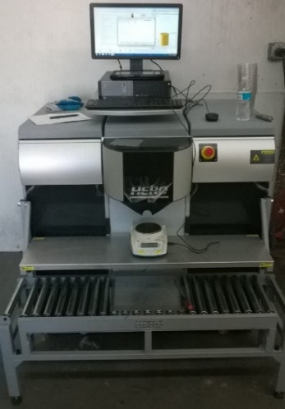 A961 Machine Newton Series

Exhibit A: The yellow hose.

